# **Steps to Cloning and Pulling/Pushing change To/from Master**

Steps to Clone herekochu repository

1. Open following URL:

<https://github.com/jungeebah/herekoCha>

1. Go to Setting

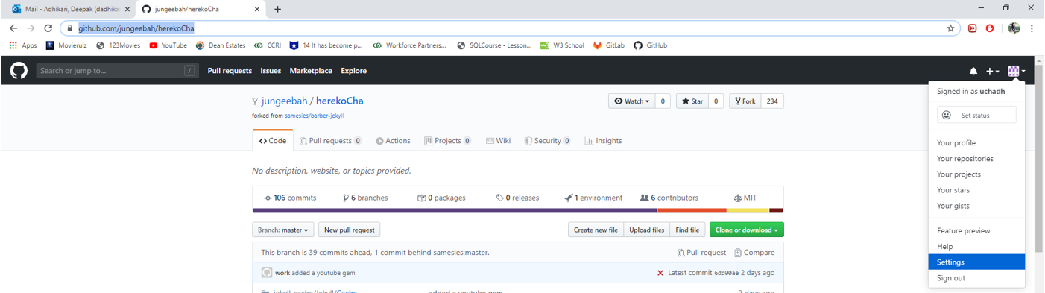

1. Click SSH and GPG keys. Here you are going to add your public SSH Key.

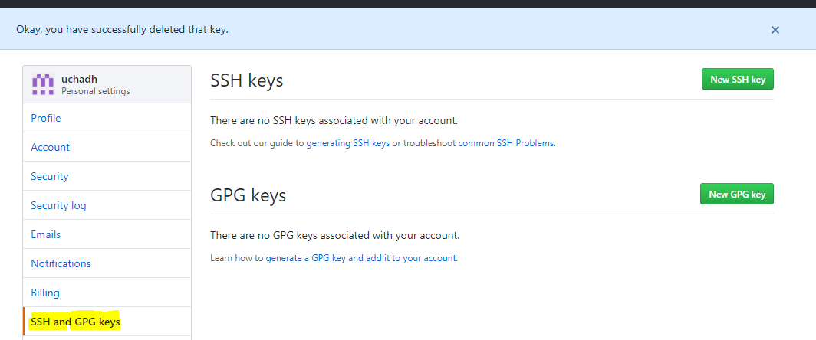

1. Open Github command line and type following

Command: ssh-keygen.exe

Hit enter where it asks questions

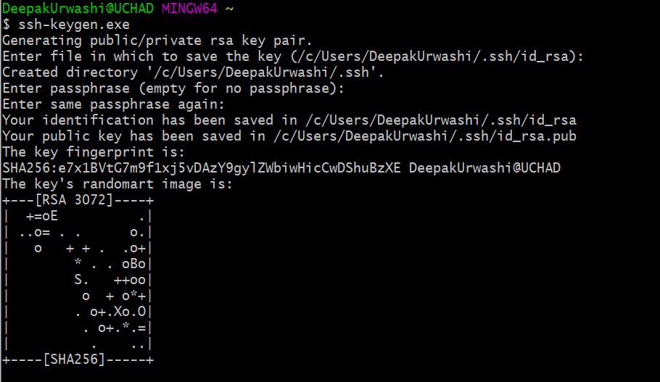

1. Config your name and email address

Command: $ git config --global user.name "Deepak"

$ git config --global user.email [dadhikari@my.ccri.edu](mailto:dadhikari@my.ccri.edu)

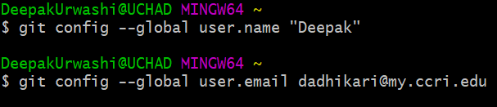

1. Verify config

Command: $ git config --list



1. Generate public key

Command: $ cat /c/Users/DeepakUrwashi/.ssh/id_rsa.pub



1. Copy the generated key and open SSH page from step -3, click on New SSH Key and paste the above copied key in key text box, provide the title and hit Add SSH key. It will ask you to login with your credential. Once logged in you will see your SHH keys will be associated with your account. This way you don’t have to enter your credential every time while making any changes to the repository.

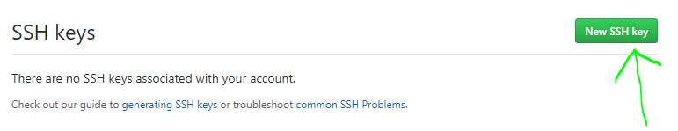

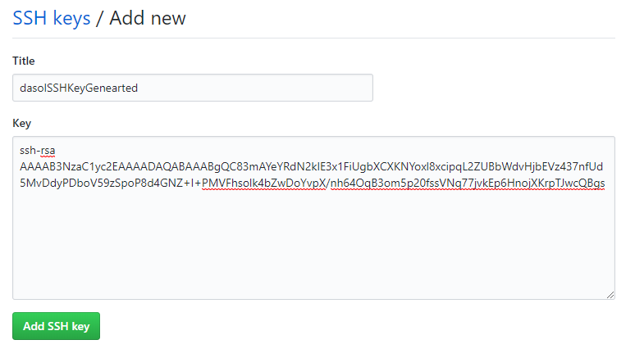

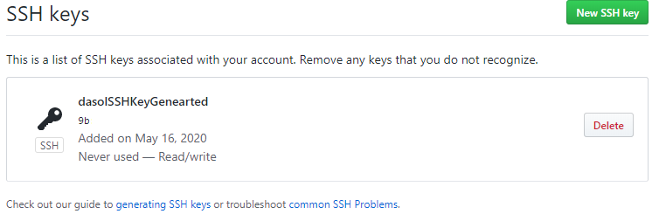

1. Make a directory in your local drive. Example: C:\GitRepo\MovieWebsiteRe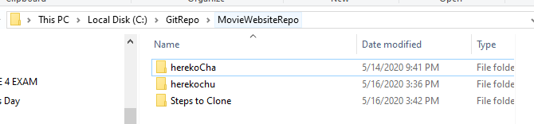
2. in Github change your working directory to the folders you created in Step -1

Command: $ cd /c/GitRepo/MovieWebsiteRepo/

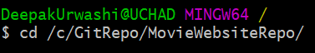

1. Clone the git repository

Command: $ git clone [git@github.com:jungeebah/herekochu.git](mailto:git@github.com:jungeebah/herekochu.git)

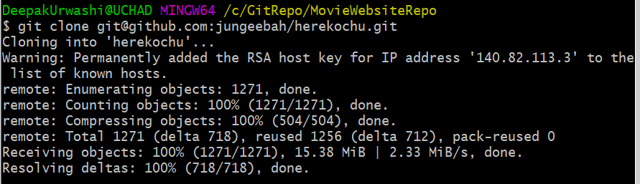

1. Change your working directory to cloned drive

Command: $ cd herekoChu



1. Fetch the server (note: You are in master branch now. This is the master branch in your local machine. Do not update/edit this branch directly. Create a local branch (Step-7) in your machine and pull/push the changes from your machine to master or vice versa.)

Command: $ git fetch



1. Pull the latest from master

Command: $git pull

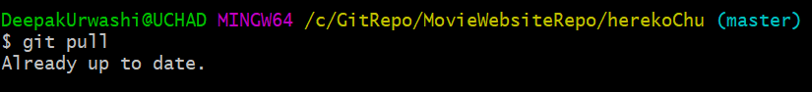

1. Create a local branch

Command: $ git checkout -b adhikary_LocalBranch

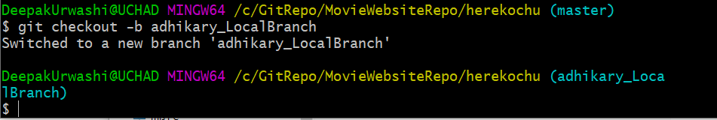

1. Checkout master or local branch. If you want to switch the branches you need to checkout that branch.

Command: $ git checkout master

$ git checkout -b adhikary_LocalBranch

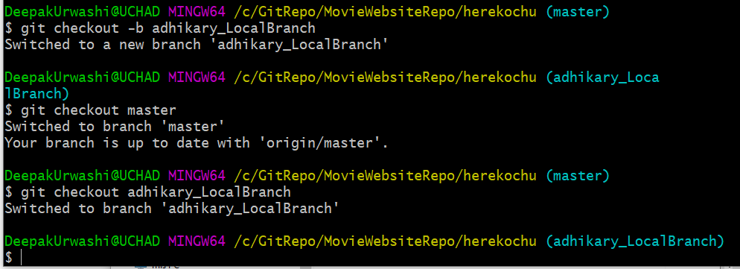

1. Merging local branch from master. First check out master and do fetching and pulling. Check out to your local branch and type following command.

Command: $ git merge master



1. Pushing your changes to master.

A. Commit (Save) your changes.

Command: $ git add .

B. Check out master and do fetching and pulling. Check out to your local branch and merge from master.

C. Push your changes. Type “$git push” and hit enter. It will give you the whole command. Copy that command and paste it and hit enter.

Command: git push --set-upstream origin adhikary_LocalBranch

